1) How to get present working folder? 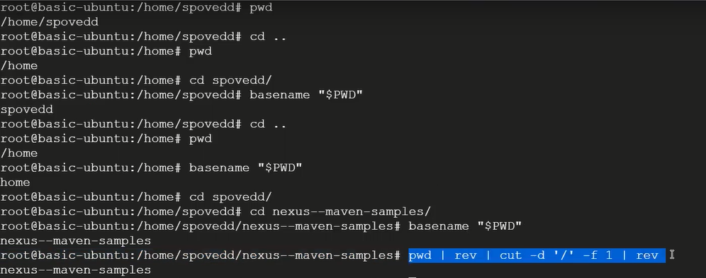
2) How to copy files from local windows machine to cloud based Linux machine? 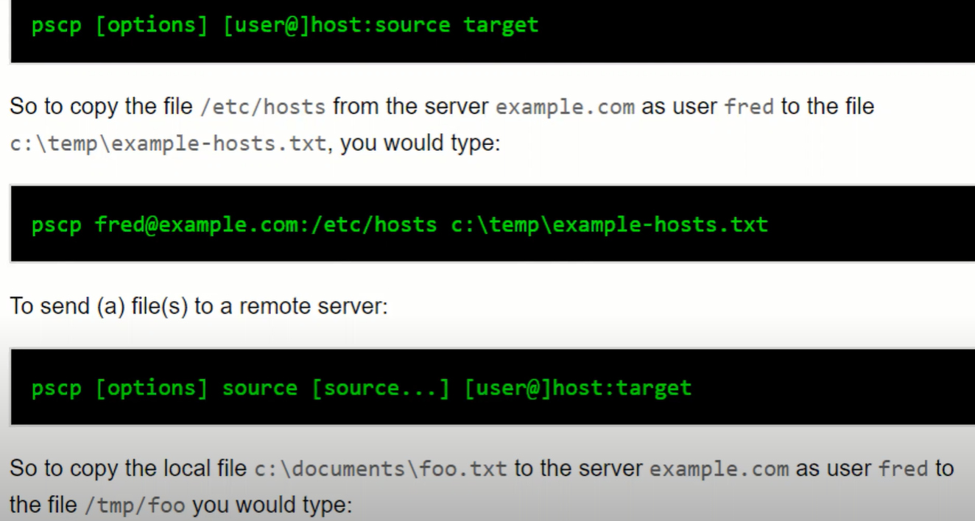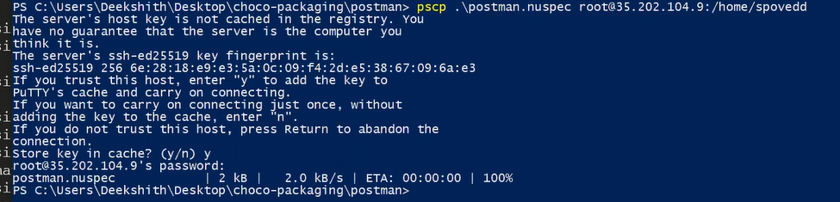
3) A shell script named test.sh can accept 4 parameters i.e, a,b,c,d. the parameters wont be supplied in order always and number of parameters might also vary( only 2 parameters user might supply sometimes), how to identify position of letter c? ( repo= Shell_Scripts => Identify_position_of_parameter.sh) 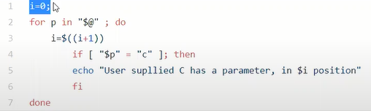
$@ - entered parameter stored in the form of array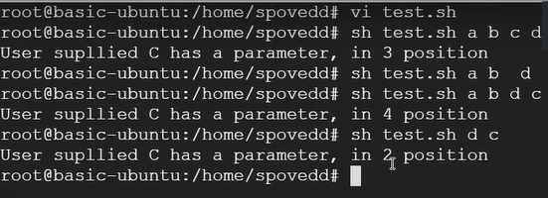
4) write a script which accepts file or folder/ a script which accepts one parameter it can be filename or folder, if its folder delete it else print "this is a file"?( repo= Shell_Scripts => delete_if_director.sh) 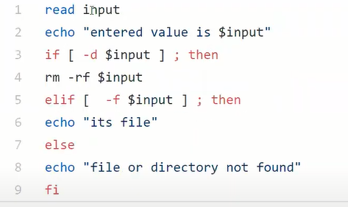
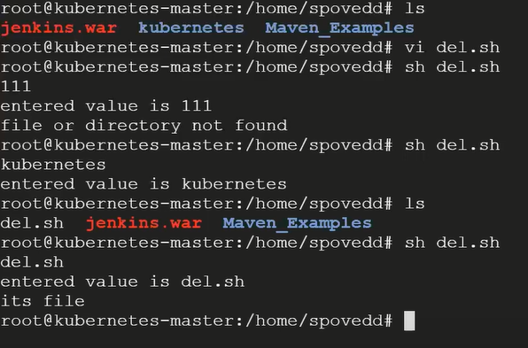
5) How to check whether particular port is already in use or not? 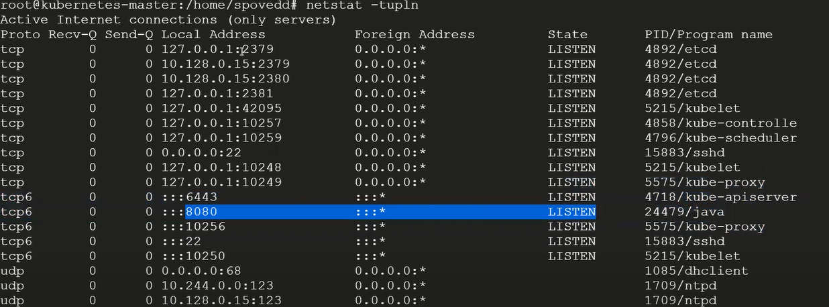

t – tcp
u – udp
pl – protocal
n – numaric

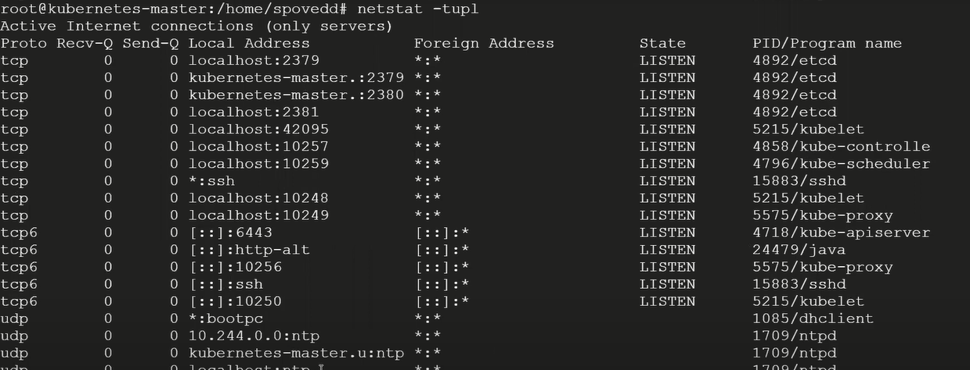
6) Logic for checking whether supplied string for a script is palindrome or not? what are all the commands you will use? (repo= Shell_Scripts => palindrome.sh)
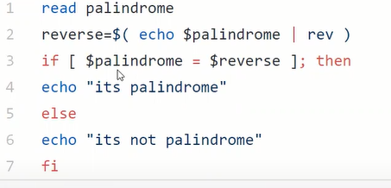
7) command to get number of lines in a file?
8) In a file I have ip addresses , I want list unique ip addresses with number of times its present in file? ( exracting IP address from logfile – youtube)
grep -E -o "([0-9]{1,3}[\.]){3}[0-9]{1,3}" logfile | sort | uniq -c | sort –nr
grep -E -o "([0-9]{1,3}[\.]){3}[0-9]{1,3}" logfile => get all the ip address in the perticular log file

If you don’t use ‘-o’ it gives the enter line 
# Uniq command will except this sorted input to achive proper output
-c number occarences
# Sort –nr => more occerance at the top (-n numeric sort & -r reverse)

9) What is exit status in UNIX?
It is used to see the previous executed command are succesfull or not echo $? If it is 0 previous command exicuted succesfully, if it a non zero last command was wrong

10) Lets say I have shell script name magic.sh when I execute. It gives “This is from magic.sh”, so now if I change file name to magic-test.sh I should get “This is from magic-test.sh” basically as name of file changes my output should also change?

11) What is shebang? Why it is used?
It will be in the beginning of your shell script which says what interpreter your using #!/bin/bash
12) Command to find empty files in a given directory?
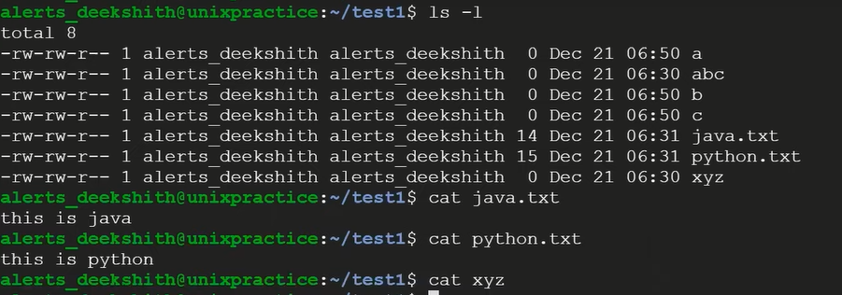
If there are 1000 of file is empty in that directory that? --- 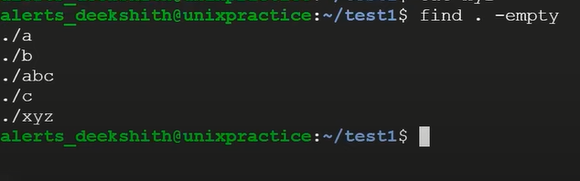
13) Commands you will use it for configuring ssh connectivity between 2 machines and what files will be present in .ssh folder?
Two have a ssh-conectivity between 2 machine first you need to have a private key and public key to generate that we use the command ssh-keygen
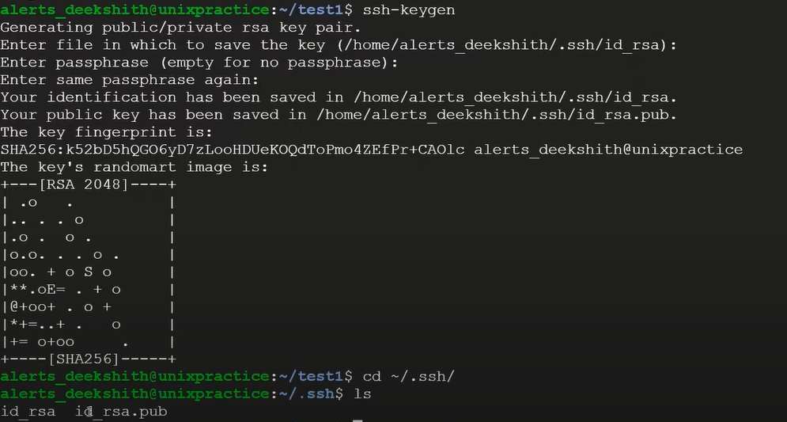
File present in .ssh => id_rsa, id_rsa.pub, knoun_hosts ( machine 2 finger print avaliable in knoun_hosts), auth_keys (when you do ssh-copy-id then public key is going to store in auth_keys file in machine2)
(Before that enable password based Authentication (target machine set passwd for root it will ask at ssh-copy-id) in /etc/ssh/sshd_config file
in case for root yes & yes and important
systemctl restart ssh.service for debain & systemctl restart sshd.service for RHEL )
To copy public key to other machine use ssh-copy-id -i root/ubuntu@privateIP
To connect other machine from my macine => ssh root@ipaddres
14) How to schedule a shell script in unix machines? 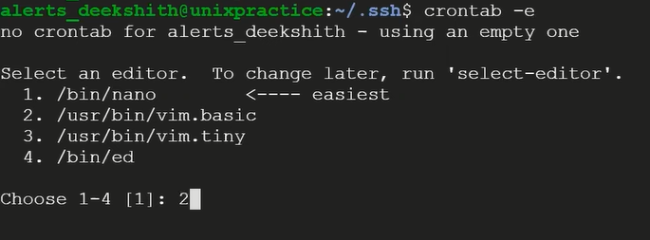 
15) Command to get load average ?
top -- 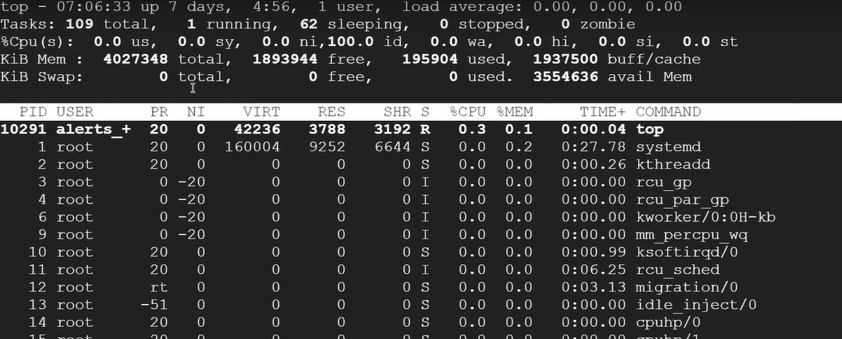
16) Need to identify ip addresses in log file and count of ip addresses in log file?
17) what is command for checking the running process? how to get PID of process?
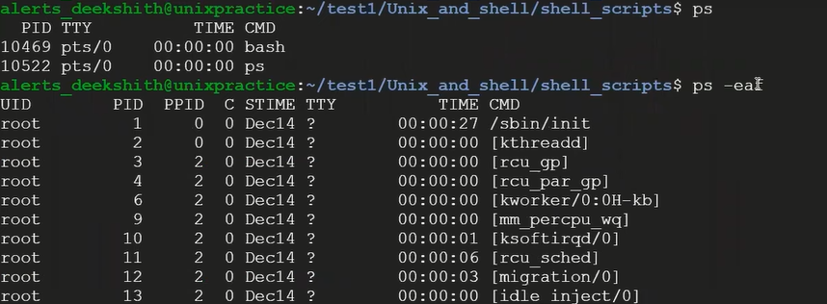
18) Command to get whether certain port is listing or not? 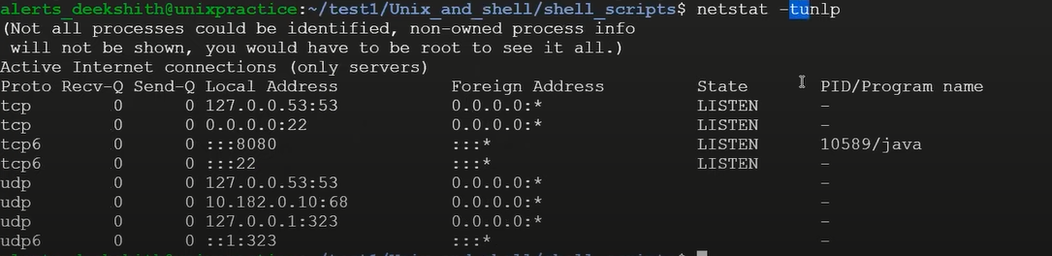
To identify what processes is running on specific port
19) How to indentify the number of params that has been sent to shell script?
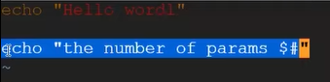 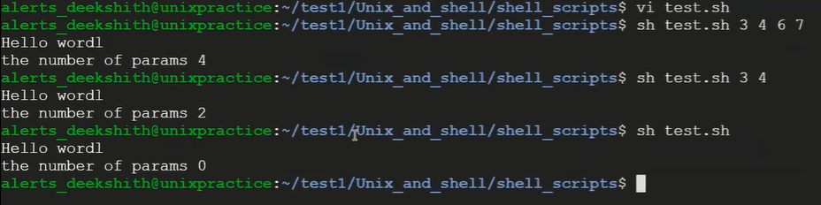20) command to delete empty line in a file? 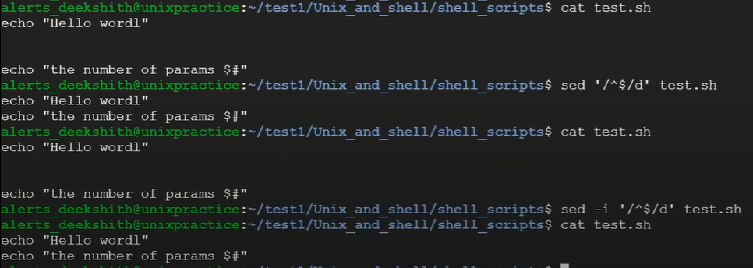
21) What is exit status? 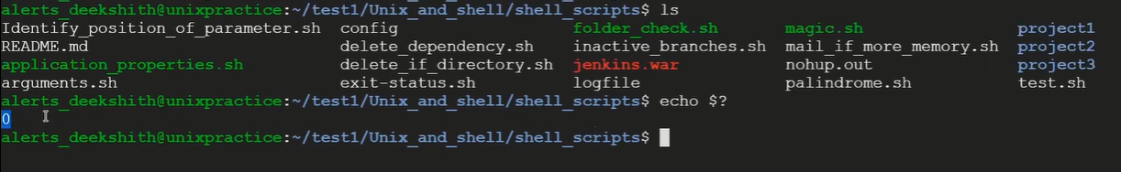
22) Given machine, how will you identify which machine it is?
To find kernel version => uname -r
23) You need to identify unused fields In values.yaml how would you approach this?

